EX NO 2
Design a UI where users recall visual elements (icons). Evaluate the effect of chunking and non-chunking on user memory.

Aim
To design and analyze a memory recall user interface using chunking and non-chunking techniques and evaluate their impact on user memory.

Tool Used
Figma

A. Home Screen (Instruction Screen)
A home screen was designed to provide instructions for the memory recall task. The screen contains a title "Memory Recall", brief instructions explaining the task, and a Start button to begin the experiment.
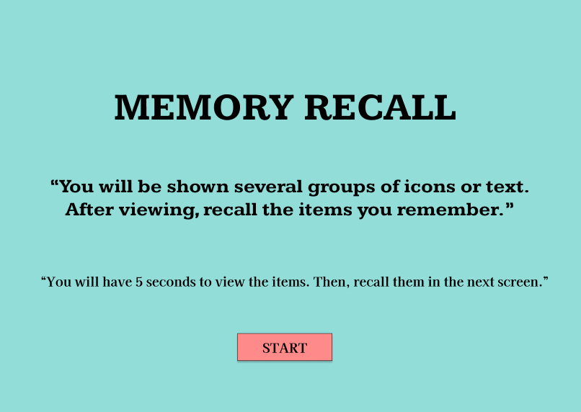

B. Chunking Phase
In the chunking phase, visual icons were grouped into meaningful chunks. Related items were placed close together with visual separation, making it easier for users to process and remember the information.
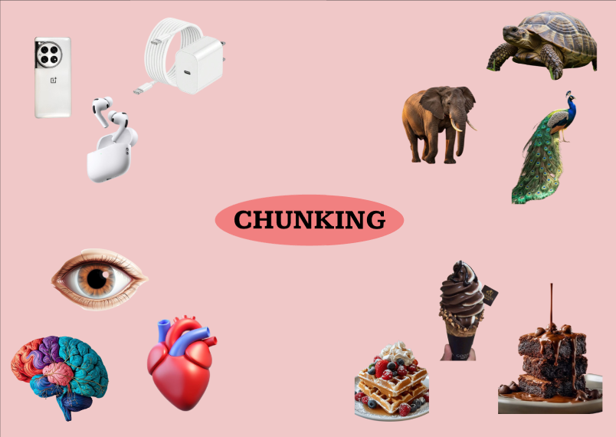

C. Non-Chunking Phase
In the non-chunking phase, the same icons were displayed randomly without grouping or visual organization. This makes recall more difficult due to cognitive overload.
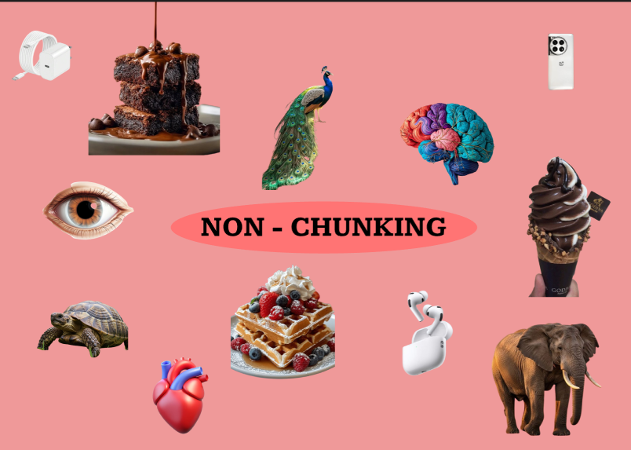

D. Recall / Evaluation Phase
Users were asked to recall the items they remembered seeing. They selected remembered icons from a list. This phase helps evaluate memory performance.
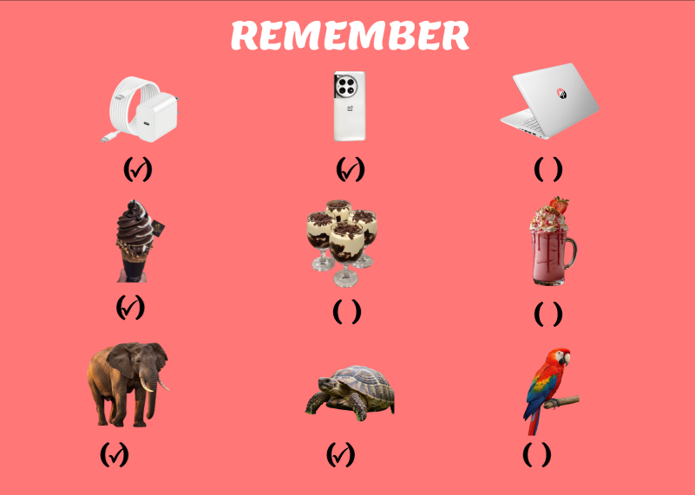

E. Result Screen
The result screen displays the user’s recall score (e.g., 5/9). This score is used to compare the effectiveness of chunking versus non-chunking.
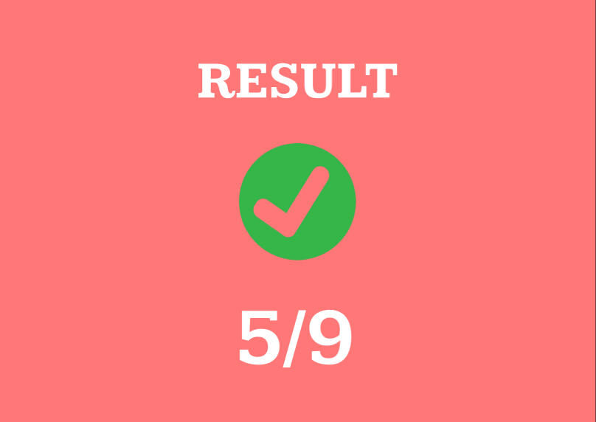

Result & Analysis
The experiment showed that users recalled more items correctly during the chunking phase compared to the non-chunking phase. Chunking reduces cognitive load and improves memory retention.

Conclusion
Chunking significantly improves memory recall when compared to non-chunking. Organizing visual elements into meaningful groups enhances user understanding and recall.

